

Semester One Examination, 2018

Question/Answer booklet

MATHEMATICS

If required by your examination administrator, please place your student identification label in this box
METHODS
UNIT 3

Section One:

Calculator-free

Student number: In figures

In words

Your name

Time allowed for this section
Reading time before commencing work: five minutes
Working time: fifty minutes

Materials required/recommended for this section
To be provided by the supervisor
This Question/Answer booklet
Formula sheet

To be provided by the candidate
Standard items: pens (blue/black preferred), pencils (including coloured), sharpener,
correction fluid/tape, eraser, ruler, highlighters

Special items: nil

Important note to candidates
No other items may be taken into the examination room. It is your responsibility to ensure that you do not have any unauthorised material. If you have any unauthorised material with you, hand it to the supervisor before reading any further.

Structure of this paper

Section | Number of questions available | Number of questions to be answered | Working  time (minutes) | Marks available | Percentage of examination
Section One:  Calculator-free | 8 | 8 | 50 | 52 | 35
Section Two:  Calculator-assumed | 13 | 13 | 100 | 98 | 65
 |  |  |  | Total | 100

Instructions to candidates

1. The rules for the conduct of examinations are detailed in the school handbook. Sitting this examination implies that you agree to abide by these rules.

2. Write your answers in this Question/Answer booklet.

3. You must be careful to confine your response to the specific question asked and to follow any instructions that are specified to a particular question.

4. Supplementary pages for the use of planning/continuing your answer to a question
have been provided at the end of this Question/Answer booklet. If you use these pages to continue an answer, indicate at the original answer where the answer is continued, i.e. give the page number.

5. Show all your working clearly. Your working should be in sufficient detail to allow your answers to be checked readily and for marks to be awarded for reasoning. Incorrect answers given without supporting reasoning cannot be allocated any marks. For any question or part question worth more than two marks, valid working or justification is required to receive full marks. If you repeat any question, ensure that you cancel the answer you do not wish to have marked.

6. It is recommended that you do not use pencil, except in diagrams.

7. The Formula sheet is not to be handed in with your Question/Answer booklet.

Section One: Calculator-free 35% (52 Marks)
This section has eight (8) questions. Answer all questions. Write your answers in the spaces provided.

Working time: 50 minutes.

Question 1 (6 marks)
A box contains five balls numbered $2, 3, 4, 5$ and $6$. Three balls are randomly drawn from the box at the same time and the random variable $X$ is the largest of the three numbers drawn.

(a) By listing all possible outcomes ($234$, $235$, etc.), determine $P(X≤5)$. (2 marks)

(b) Construct a table to show the probability distribution of $X$. (2 marks)

(c) Calculate $E⁡(X)$. (2 marks)

Question 2 (5 marks)
A function defined by $f\left(x\right)=13+18x-6x^{2}-2x^{3}$ has stationary points at $(1, 23)$ and $(-3, -41)$.

(a) Use the second derivative to show that one of the stationary points is a local maximum and the other a local minimum. (3 marks)

(b) Determine the coordinates of the point of inflection of the graph of $y=f(x)$. (2 marks)

Question 3 (5 marks)
A particle travels in a straight line so that its distance $x$ cm from a fixed point $O$ on the line after $t$ seconds is given by
$$x=\frac{3t^{3}}{2t+1}, t≥0.$$

Calculate the acceleration of the particle when $t=1$.

Question 4 (8 marks)
The graph of $y={\left(3-2x\right)}^{3}$ is shown below.

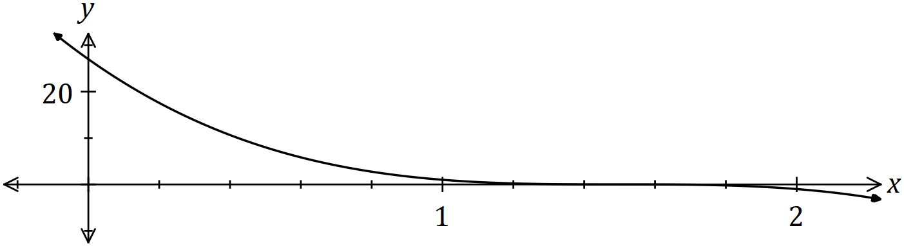

(a) Determine the area of the region enclosed by the curve and the coordinates axes.
(4 marks)

(b) Given that the area of the region bounded by the curve, the $x$-axis and the line $x=k$ is $8$ square units, determine the value of $k$, where $0<k<1.5$. (4 marks)

Question 5 (7 marks)
Determine $\begin{matrix}dy \\ \overline{dx}\end{matrix}$ for the following, simplifying each answer.

(a) $y=\sqrt{5-6x}$. (2 marks)

(b) $y=3x^{4}\sin{(4x)}$. (3 marks)

(c) $y=\int_{x}^{2}{\underset{ }{\overset{ }{\begin{matrix}1 \\ \overline{\sqrt{1+t}}\end{matrix}}}}dt$. (2 marks)

Question 6 (5 marks)
The height, in metres, of a lift above the ground $t$ seconds after it starts moving is given by

$$h=2\cos^{2}\left(\begin{matrix}t \\ \overline{5}\end{matrix}\right).$$

Use the increments formula to estimate the change in height of the lift from $t=\begin{matrix}5π \\ \overline{ 6 }\end{matrix}$ to $t=\begin{matrix}17π \\ \overline{ 20 }\end{matrix}$.

Question 7 (9 marks)
The function $g$ is such that $g^{'}\left(x\right)=ax^{2}+18x+b$, it has a point of inflection at $(-1, 29)$ and a stationary point at $(1, -19)$.

(a) Determine $g(2)$. (5 marks)

(b) Determine

(i) $\int_{1}^{2}{\underset{ }{\overset{ }{g'(x)}}}dx$. (2 marks)

(ii) $\int_{1}^{2}{\underset{ }{\overset{ }{4g'(x)}}+16}dx$. (2 marks)

Question 8 (7 marks)
Two houses, $P$ and $Q$, are $900$ m apart on either side of a straight railway line $AC$. $AC$ is the perpendicular bisector of $PQ$ and the midpoint of $PQ$ is $B$. A small train, $R$, leaves station $C$ and travels towards $B$, $1200$ m from $C$.

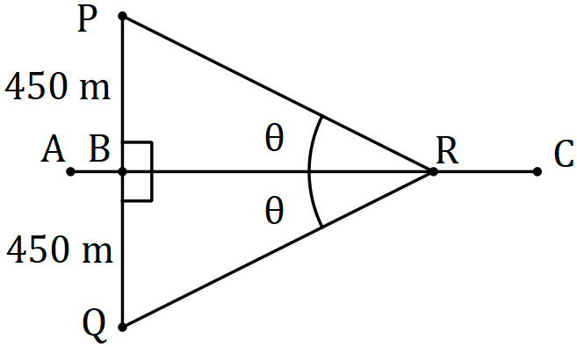

Let $∠PRB=∠QRB=θ$, where $0<θ<90°$, and $X=PR+QR+CR$, the sum of the distances of the train from the houses and station.

(a) By forming expressions for $PR, BR$ and $CR$, show that $X=1200+\begin{matrix}450(2-\cos{θ}) \\ \overline{\sin{θ} }\end{matrix}$ .
(3 marks)

(b) Use a calculus method to determine the minimum value of $X$. (4 marks)

Supplementary page

Question number: _________

Markers use only
Question | Maximum | Mark
1 | 6
2 | 5
3 | 5
4 | 8
5 | 7
6 | 5
7 | 9
8 | 7
S1 Total | 52
S1 Wt (×0.6731) | 35%
S2 Wt | 65%
Total | 100%

